**Automate Start-Stop EC2 Instances Using Lambda - Step-by-Step Guide**

1. Lunch the instance
2. Create the IAM Policy
3. Create IAM role
4. Create the 2 Lambda Function for start and stop
5. Cloud Watch
6. Create a role for start and stop.

**Step 1: Launch the EC2 Instance**

* Navigate to EC2 Console.
* Launch a new EC2 instance with the desired configuration.
* Note the **Instance ID** and **Region**.

**Step 2: Create IAM Policy**

1. Go to **IAM > Policies > Create policy**

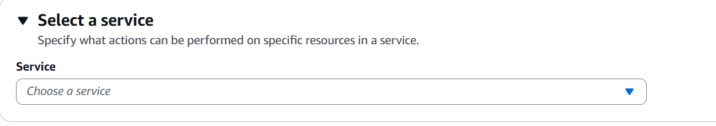

1. Choose **Service**: EC2
2. Choose **Actions:** Start Instances, Stop Instances

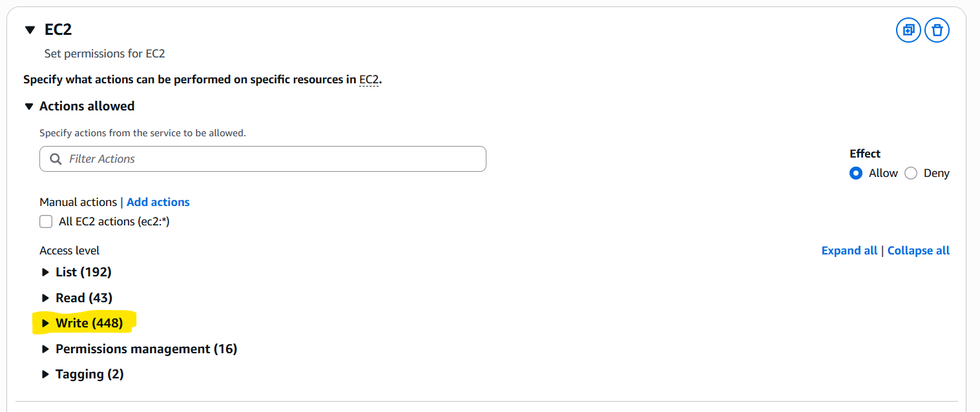

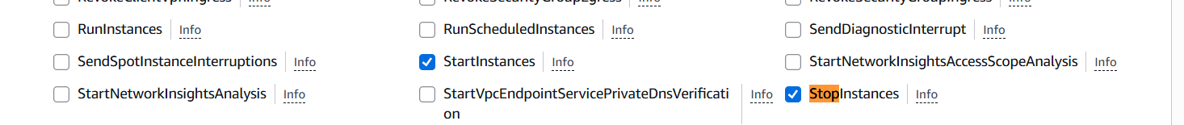

1. Under **Resources**, choose All resources OR specify the ARN of your EC2 instance.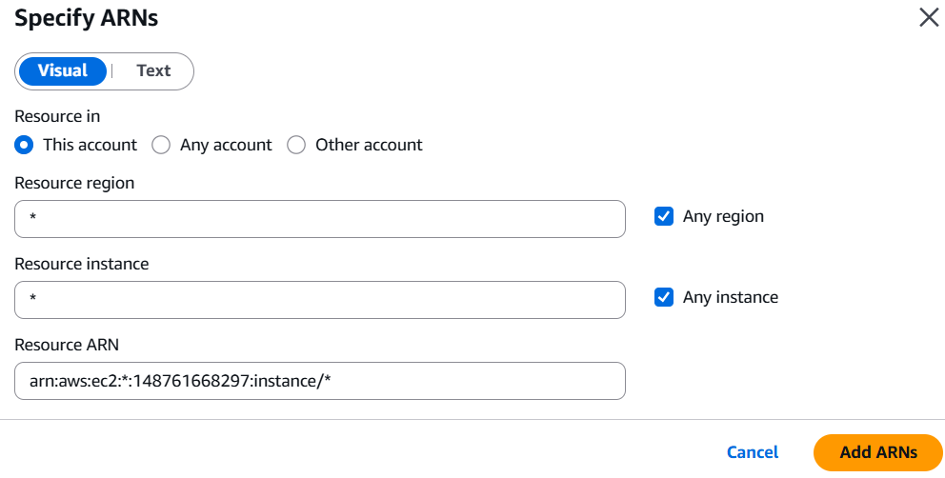
2. Click **Next**, give your policy a name like EC2StartStopPolicy, and **create the policy.**

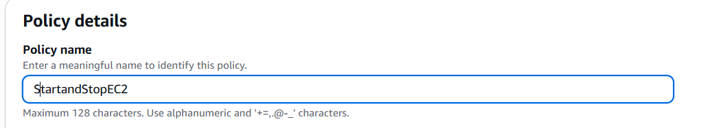

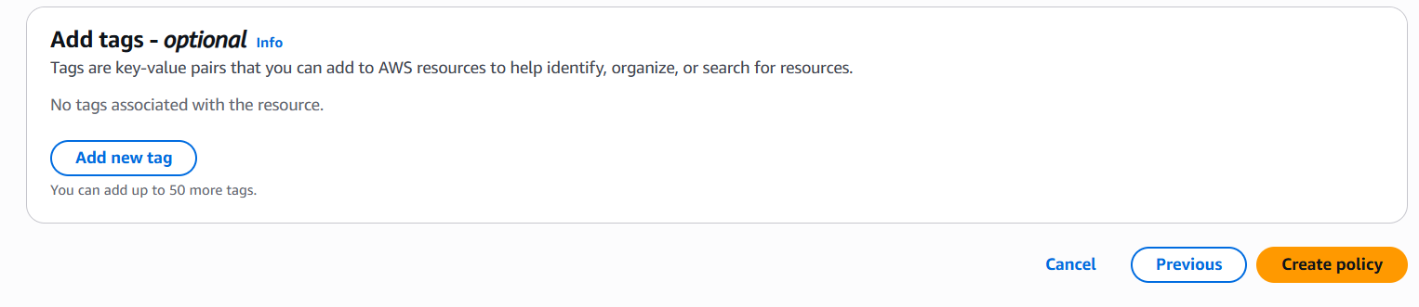

**Step 3: Create IAM Role for Lambda**

1. Navigate to **IAM > Roles > Create Role**.
2. **Trusted entity type: AWS Service**
3. **Use case 🡪 Service or use case 🡺 Lambda**

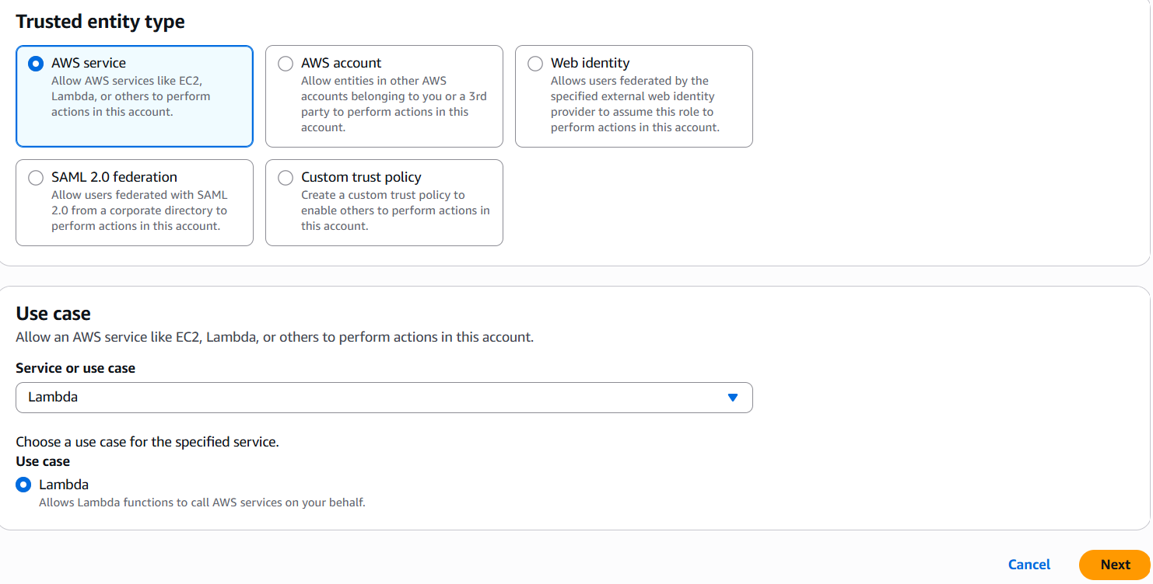

1. **Permissions policies 🡪 Attach the policy created in Step 2.**

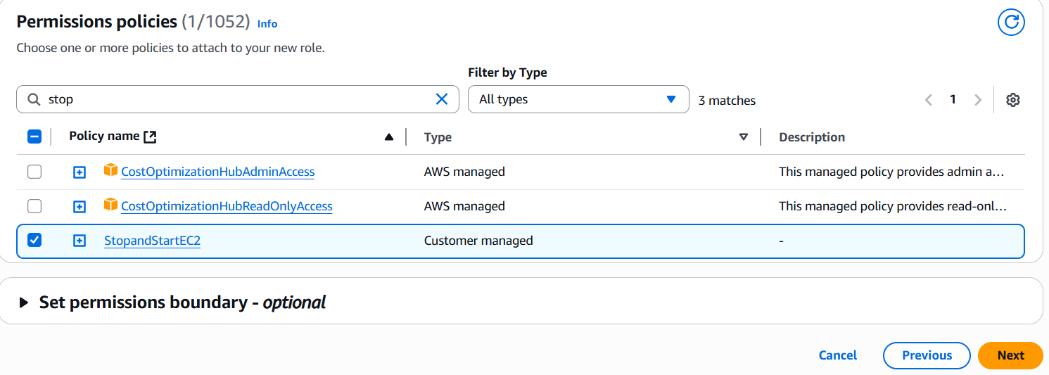

1. Name the role (e.g., LambdaEC2StartStopRole) and create it.
2. Role 🡪 Trust policy 🡪 Edit the **trust policy** and modify it to allow scheduler.amazonaws.com.

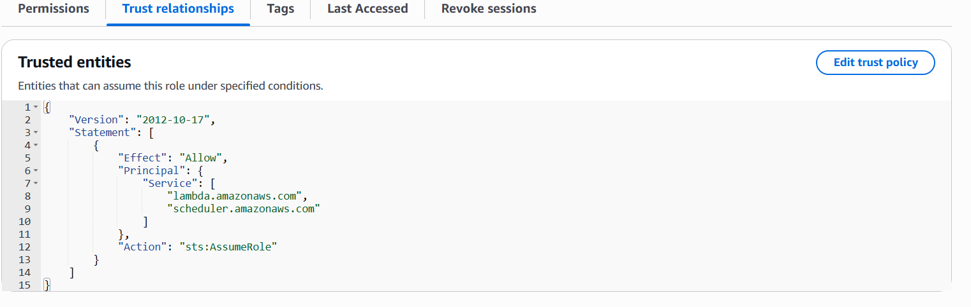

**Step 4: Create Lambda Functions (Start and Stop EC2)**

1. Create a function
2. Choose the option **Author from scratch.**
3. **Basic Information 🡪 Function name 🡪 Give the name**
4. **Runtime 🡪** Choose the language to use to write your function. Note that the console code editor supports only Node.js, Python, and Ruby. 🡪 **Python 3.9**

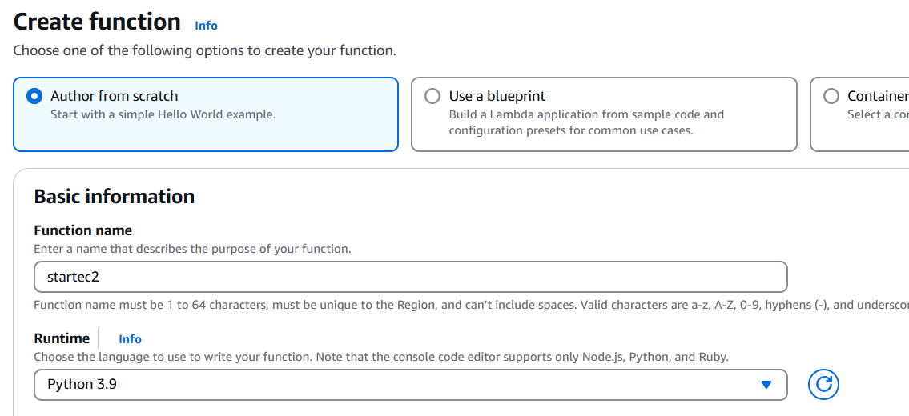

1. **Change default execution role 🡪 Use an existing role 🡪** Choose an existing role that you've created to be used with this Lambda function. The role must have permission to upload logs to Amazon CloudWatch Logs. 🡪 Select the IAM role 🡪 **Create Function**

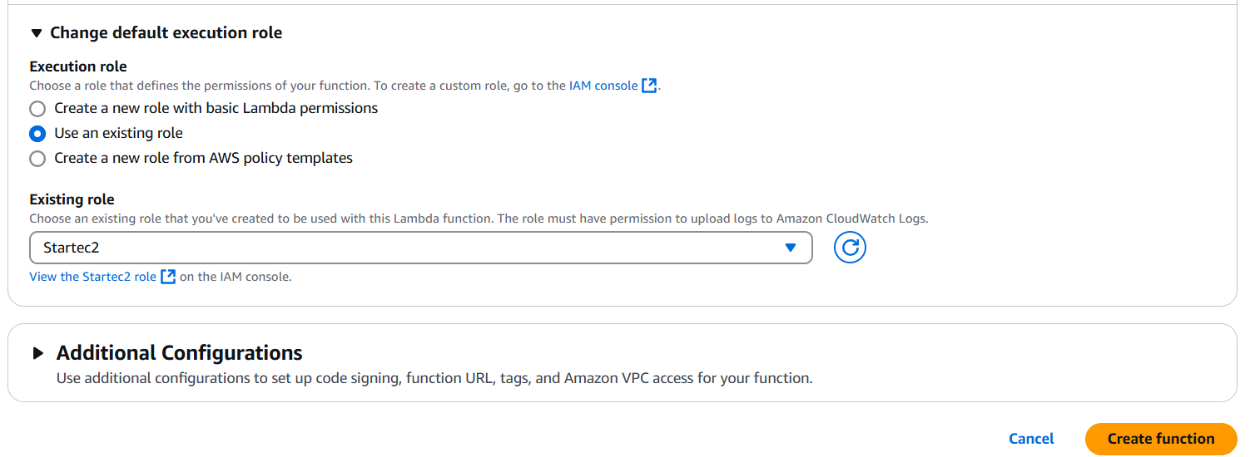

1. Code 🡪 Take example code for start the ec2 lambda function python 3.9 🡪 Give the your EC2 region 🡪 EC2 Instance ID.

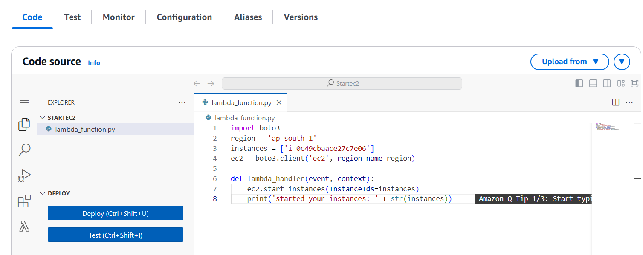

1. Deploy 🡪 Test (Automaticallyec2 instance will get start)

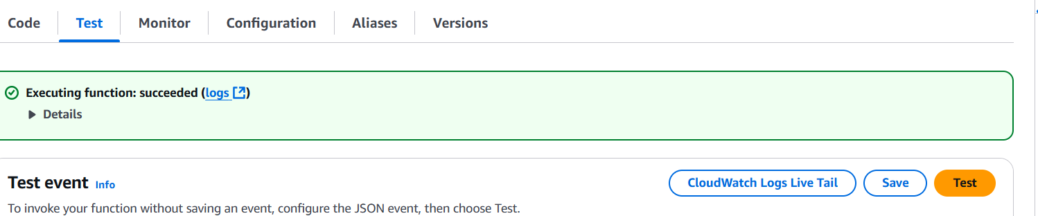

1. Check the EC2 instance state.

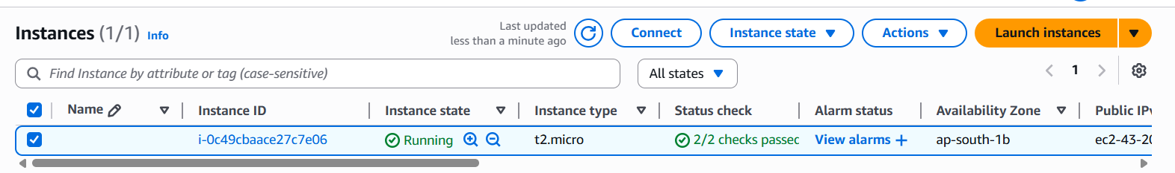

**Step 5: Schedule with Amazon Event Bridge (CloudWatch Events)**

1. Events 🡪 Role 🡪 Create Role.
2. **Define rule detail 🡪 Name (Startec2) 🡪 Schedule**
3. **Specify schedule detail 🡪 Schedule pattern 🡪 Recurring schedule**

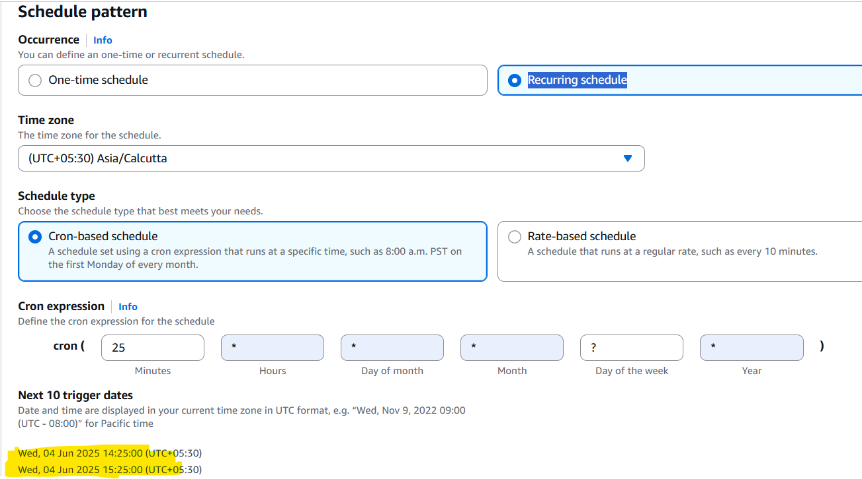

1. **Flexible time window 🡪 OFF**
2. **Select target 🡪 AWS Lambda**

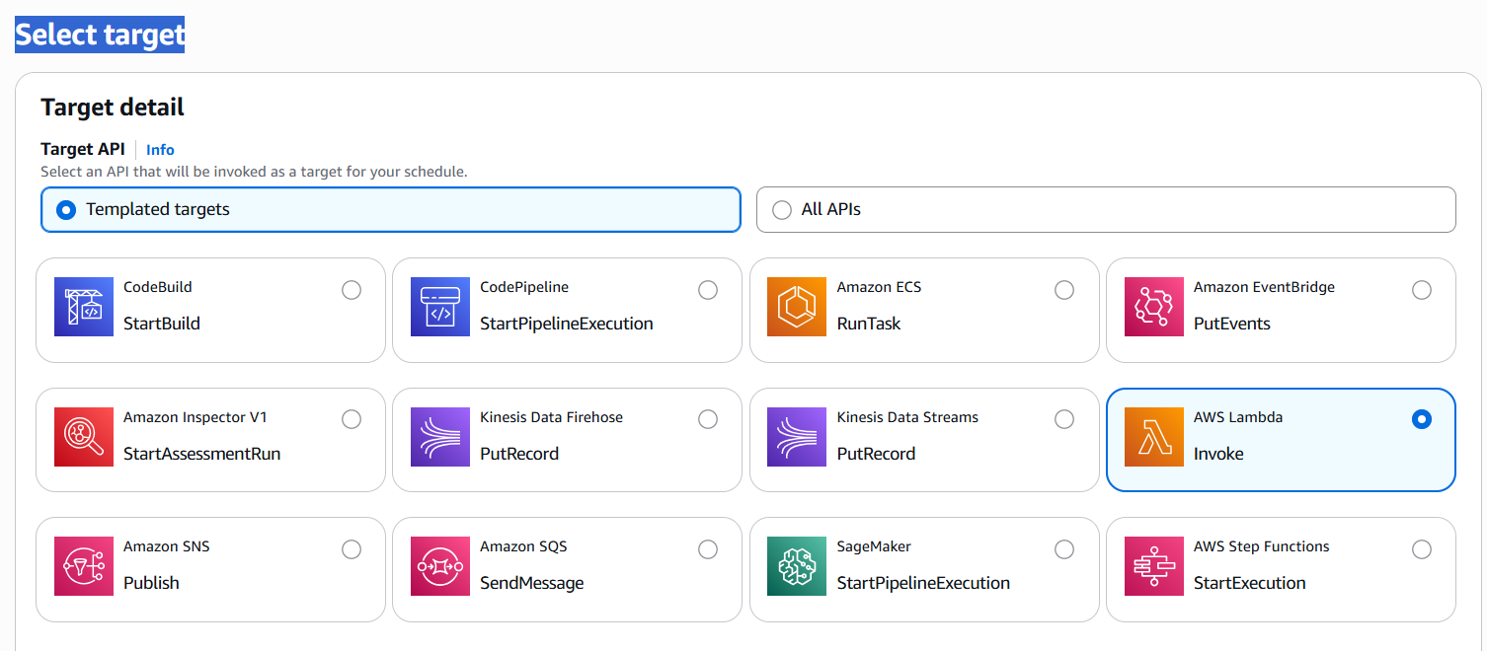

1. **Invoke 🡪 Lambda function 🡪 Select the lambda function.**

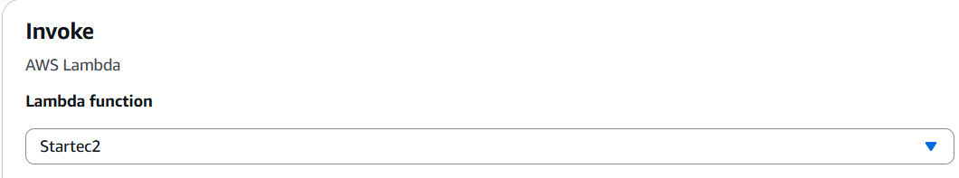

1. **Permissions** 🡪 **Execution role 🡪 Create new role for this schedule 🡪 specify the name to Identify easily.**

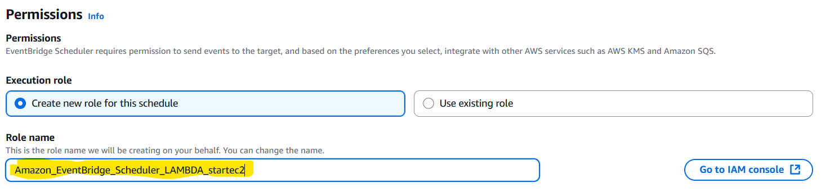

1. Click on Next 🡪 Create schedule.

**Validation**

* Monitor the EC2 instance state from the EC2 dashboard.
* Check logs under **CloudWatch Logs > Log groups > /aws/lambda/{FunctionName}** to ensure the Lambda is working correctly.

**Optional: Add Notifications**

* You can integrate Amazon SNS or CloudWatch Alarms to receive notifications for instance start/stop events.